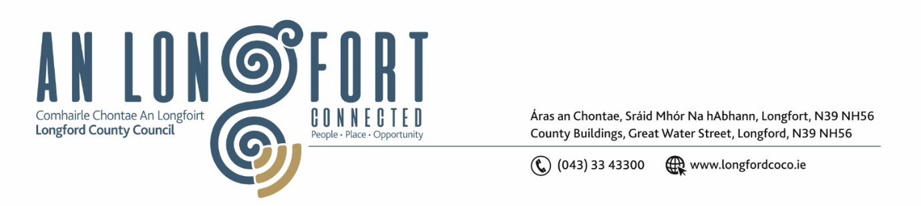

***LONGFORD MUNICIPAL DISTRICT***

***Please note meeting will be held in the Council Chamber, Aras an Chontae and via Microsoft Teams***

**15 March 2022.**

**To: Each Member of Longford Municipal District.**

**Dear Member,**

You are requested to attend the Meeting of Longford Municipal District to be held in **the Council Chamber, Aras An Chontae** and **via Microsoft Teams** on **Wednesday 23 March 2022 at 10.15am** to transact business, as set out on the Agenda hereunder.

**Yours sincerely**,

Ann Marie Mc Keon

_______________

**Ann Marie Mc Keon**

**Meetings Administrator.**

**AGENDA**

Prayer before meeting.

**1.** Confirmation of Minutes -

1. Longford Municipal District Meeting held on Wednesday 23 February 2022– copy enclosed.
2. Longford Municipal District Committee Meeting held on Wednesday 23 February 2022 – copy enclosed.

**2.** Matters arising from Minutes.

**3.** Declaration of Interest by Members.

**4.** Management Report - enclosed.

**5**. Proposed Projects/Expression of interests.

**6.** Consideration of Schedule of Longford Municipal District Works – enclosed